Data Modelling Project Documentation

Johan Goh (G00388771), Guan Xian Chua (G00397903)

2022

## Company

Zendesk is a customer relationship management (CRM) software-as-a-service (SaaS) provider, where their software is also called Zendesk. Zendesk is designed to make the customer support process simpler, with an in-built ticketing and communication service. Zendesk also has an in-built analytics system, allowing managers to view at a glance statistics.

## Mission Statement

To provide a software service to streamline and simplify the ticketing system for other companies.

## Objectives of Database

* To keep track of all entities within the ticketing software (Zendesk)
* To be able to view at a glance the employee-ticket resolution distribution using queries i.e. which employee resolved the most tickets
* To store overall reviews received such that managers are able to see overall performance of the company.

## Database brainstorming

* Employee management system
* Stock management system
* Customer Relationship Management (CRM) system
* Shipping system
* Ticketing system

## Zendesk Ticketing System

1. Tickets are put up on the application for employees to see
2. Employees are able to take any tickets to solve
3. Chat function is opened with customer to address problem
4. If they are unable to solve, will raise to higher ups
5. If solved, ticket is resolved and review is requested from customer

## Table Brainstorming

* Tickets
  + Description
  + High Priority
  + Customer
* Employees
* Customers
* Reviews
* Action
  + Description
  + Access Level (some info may only be accessible by employees of higher ranking)
  + Employee (who made this action) (PK FK)
  + Ticket (that this action was made in) (PK FK)

|  |  |  |  |  |  |
| --- | --- | --- | --- | --- | --- |
| **Tickets** | **Customers** | **Employees** | **Reviews** | **Actions** | **Ticket Actions** |
| Ticket ID (PK) | Customer ID (PK) | Employee ID (PK) | Customer ID + Ticket ID (PK) | Action ID (PK) | Ticket ID + Action ID (PK) |
| Date | Name | Name | Rating | Description | Employee ID (FK) |
| Time | Contact Info | Contact | Comments | Category | Outcome |
| Customer ID (FK) |  | Department | Ticket ID (FK) |  |  |
| Description |  | Role | Date |  |  |
| Priority Level |  |  | Time |  |  |

## Assumptions / Business Rules

* A customer can create multiple tickets, but each ticket will only be tied to 1 customer
* Each ticket can have multiple actions and employees and vice versa, creating a many-many relationship, hence an intermediary entity [Ticket Actions] was created.
* Each ticket action can only have 1 action and 1 employee, but each action and employee can have multiple ticket actions.
* A ticket will not have duplicate issues arising in duplicate actions i.e. each action can only be done a maximum of 1 time
* Reviews are only requested once a ticket is resolved, hence the date and time signifies when the ticket was closed
* Review rating is optional and will default to NULL if the customer skips this, but there will always be a review tied to a ticket
* Employees follow a manual of predetermined actions with a unique ID tied to each action based on the ticket (hence creating an [Actions] entity)

## Normalisation

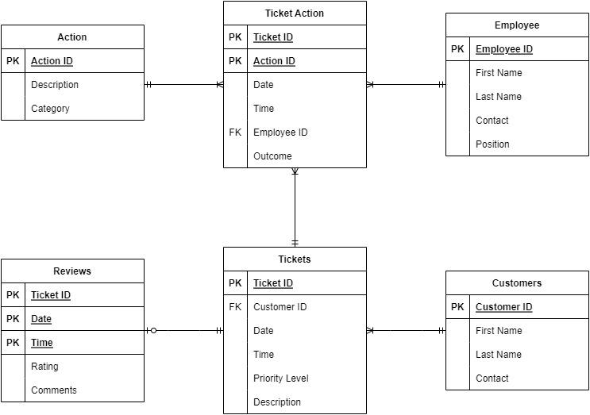

After reviewing our initial ERD, we found that all the tables were already 1st, 2nd and 3rd normal form compliant, as we had already removed all dependencies and many-many relationships within the ERD. Hence, no normalisation was carried out on the ERD.

## Work Breakdown

|  |  |
| --- | --- |
| **Item** | **Member(s)** |
| Brainstorming | All |
| Document Writing | Johan |
| Assumptions | Johan |
| ERD draw.io | Guan Xian |
| Access: Table Creation | Guan Xian |
| Access: Sample Data | Johan |
| Access Switchboard | All |
| Access Queries & Reports: Customer Tickets, Average Ratings by Employee, Ticket Actions Completed by Employee | Johan |
| Access Forms: Customer Tickets Form, Employee Ticket Actions Form | Johan |
| Access Queries & Reports: Action By Ticket, Number of Actions by Employee | Guan Xian |
| Access Forms: Action By ticket Form | Guan Xian |
| Access Settings (Opening on switchboard & locked navigation) | Johan |

### 9.1. Document Writing Breakdown

